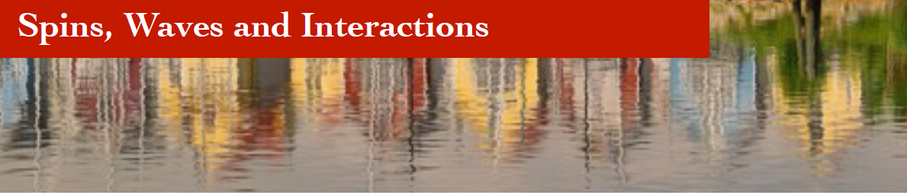
Registration: Spins, Waves and Interactions 2026
August 24 – August 26, 2026, Krupp Kolleg, Greifswald

1 Personal Information
First and last name
Affiliation (name tag)
Email address

2 Contribution
Title of contribution

Contribution: invited poster

3 Social Events
Dinner Aug 24
Dinner Aug 25
Excursion Wendelstein Aug 26

Please return until July 31, 2026 (latest) to michaela.lammel@uni-konstanz.de.
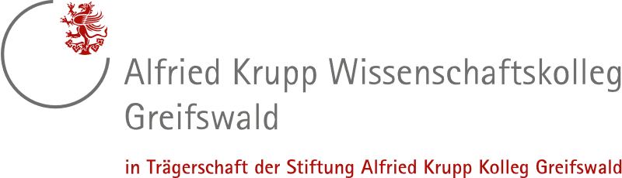
Graciously sponsored by:
