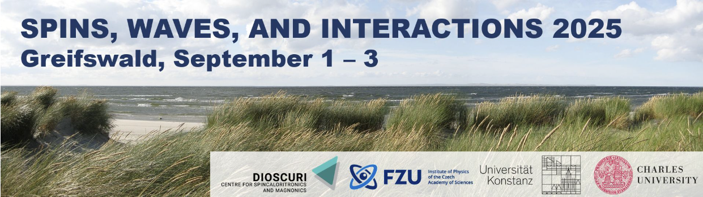

**Program Overview:**

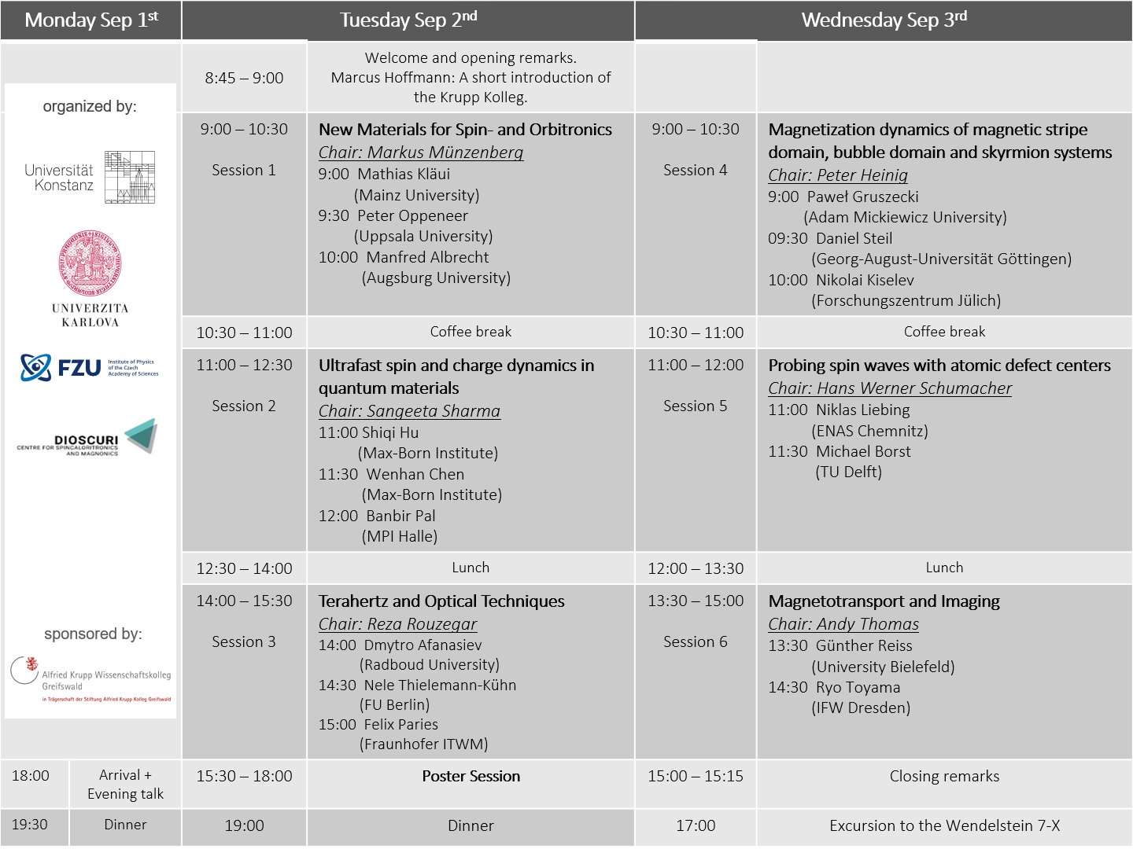

**Monday, 1st September 2025**

18:00 Public evening talk at the Krupp Kolleg (in German)

*Elektronische Nervenzellen*   
Andy Thomas

19:30 Dinner (Brasserie Hermann, Anklamer Str. 108)

**Tuesday, 2nd September 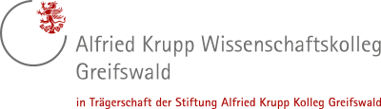2025**

8:45 – 9:00 Welcome and opening remarks

**9:00 – 10:30 *New Materials for Spin- and Orbitronics***  (Chair: Markus Münzenberg – Uni Greifswald)

**9:00 Mathias Kläui**, Mainz University *Efficiency of orbital effects for spintronics*

**9:30 Peter Oppeneer**, Uppsala University *Emergent field of orbitronics: Theory developments*

**10:00 Manfred Albrecht**, Augsburg University *Antiferromagnetic Oxide Thin Films for Spintronic Applications*

10:30 – 11:00 Coffee break

**11:00 – 12:30 *Ultrafast spin and charge dynamics in quantum materials***(Chair: Sangeeta Sharma - Max-Born Institute)

**11:00 Shiqi Hu**, Max-Born Institute

*Ultrafast Dynamics of Nonadiabatic and Nonequilibrium Electron-  
 Phonon Interactions*

**11:30 Wenhan Chen**, Max-Born Institute *Micro- and macroscopic quantum details of complex spin-textures*

**12:00 Banbir Pal**, MPI Halle

*Electrical switching of chiral kagome antiferromagnet Mn3Sn by a  
 seeded spin-orbit torque*

12:30 – 14:00 Lunch

**14:00 – 15:30 *Terahertz and Optical Techniques*** (Chair: Reza Rouzegar – FU Berlin)

**14:00 Dmytro Afanasiev**, Radboud University *Light-driven antiferromagnetic magnonics*

**14:30 Nele Thielemann-Kühn**,Helmholtz-Zentrum Berlin

*Electronic excitation in 4f rare-earth metals and their role for  
 magnetic order dynamics*

**15:00 Felix Paries**, Fraunhofer ITWM Kaiserslautern

*Spatio-temporally resolved spintronic terahertz emission nanoscopy*

**15:30 – 18:00 *Poster Session*** (presentations listed on last pages)

19:00 Dinner (Goldmarie, Fischstr. 11)

**Wednesday, 3rd September 2025**

**9:00 – 10:30 *Magnetization dynamics of magnetic stripe domain, bubble  
 domain and skyrmion systems*** (Chair: Olav Hellwig – TU Chemnitz)

**9:00 Paweł Gruszecki**, Adam Mickiewicz University *Dynamics of spin waves in thin films with perpendicular anisotropy   
 near the phase transition to stripe domain phase*

**09:30 Daniel Steil**, Georg-August-Universität Göttingen *Optical Creation and Control of Magnetic Spin Textures*

**10:00 Nikolai Kiselev**, Forschungszentrum Jülich

*Topological magnetic solitons stabilized by demagnetizing fields*

10:30 – 11:00 Coffee break

**11:00 – 12:00 *Probing spin waves with atomic defect centers*** (Chair: Hans Werner Schumacher – PTB Braunschweig)

**11:00 Niklas Liebing**, ENAS Chemnitz *Frequency multiplication by collective nanoscale spin-wave dynamics* **11:30 Michael Borst**, TU Delft

*Scanning NV microscopy of spin waves*

12:00 – 13:30 Lunch

**13:30 – 15:00 *Magnetotransport and Imaging*** (Chair: Andy Thomas – IFW Dresden)

**13:30 Günther Reiss**, Bielefeld University *New Materials and Interface Effects in Charge and Spin Transport in   
 Magnetic Heterostructures* **14:30 Ryo Toyama**, IFW Dresden *High-throughput characterization of transport properties in spintronic  
 materials using combinatorial experiments*

15:00 Closing remarks

17:00 Excursion at the Wendelstein 7-X

**Poster presentations:**

1. **Abram, Robin** (& Reuter, Ricarda)(PTB Braunschweig)  
   *Height Calibration of Nitrogen Vacancy Diamond Tips Using Current-Carrying Wires*
2. **Behovits, Yannic** (Freie Universität Berlin) *Terahertz switching of an antiferromagnet*
3. **Engelke, Fabian** (JLU Giessen) *Realistic Modeling of Temperature-Induced Spin Disorder in Magnetic Materials using Quantum Statistics and Anharmonic Effects*
4. **Grisk, Holger** (Uni Greifswald / IJL Nancy) *Probing ultrafast spin currents in thick copper layers*
5. **Heinig, Peter** (TU Chemnitz) *Parallel Stripe Domains in Tilted Magnetization Systems: From a Single Point of Irreversibility to Spin-Wave Interactions*
6. **Hellwig, Olav** (TU Chemnitz)  *Tuning magnetic field reversal modes and domain structure in perpendicular anisotropy synthetic antiferromagnets*
7. **Herbst, Franz** (University of Konstanz) *Probing magnetic fluctuations with Femtosecond Spin Noise Spectroscopy*
8. **Heyen, Hauke Lars** (Uni Greifswald) *Skyrmion dynamics in Ta/CoFeB/MgO at room temperature*
9. **Kim, Peter** (Radboud University) *Ultrashort spin wave pulses in canted antiferromagnets*
10. **Kimoto, Yuta** (Tohoku University / University of Konstanz) *Current-induced sliding motion in a helimagnet MnAu2*
11. **KM Shivangi Shukla** (Cavendish laboratory, University of Cambridge) *Complex Conductivity of Superconducting NbN film using THz Spectroscopy*
12. **Kredl, Jana** (Uni Greifswald) *Applications of 3D Nano-Lithography in Magnetism*
13. **Liebermann, Peer** (FU Berlin) *THz Emission spectroscopy with fiber-based laser source*
14. **Nabben, Nadine** University of Konstanz *Magnetization fluctuations probed via the anomalous Hall effect*
15. **Reustlen, Denise** (University of Konstanz) *Quantitative study of the spin Hall magnetoresistance in yttrium iron garnet/Pt heterostructures*
16. **Reuter, Ricarda** (& Abram, Robin)(PTB Braunschweig)  
    *Height Calibration of Nitrogen Vacancy Diamond Tips Using Current-Carrying Wires*
17. **Rosinus Serrano, Bruno** (Freie Universität Berlin) *THz spin-orbit fields in NiMnSb*
18. **Ruge, Amon** (FU Berlin) *Terahertz induced Orbital Hall dynamics in V*
19. **Schlörb, Heike** (IFW Dresden) *Magnetotransport in TaSb2 single crystals*
20. **Singh, Roshani** (IIT Allahanbad)  
    *Light-Matter Interaction and Ultrafast Spin Relaxation in Magnetic Topological Interfaces*
21. **Skobjin, Gregor** (University of Konstanz) *Magnetic aftereffect and Barkhausen effect in thin films of the altermagnetic candidate Mn5Si3*
22. **Wittrock, Steffen** (Helmholtz-Zentrum Berlin) *Reciprocal space imaging of sub-100 nm nonlinear spin wave interactions*

